## Evaluating Statistical Bounding Methods for Semi-Quantitative Non-Targeted Analysis Using ENTACT Data (R Markdown)

Louis C. Groff II

2/25/2021

This markdown document shows the statistical methods performed for the ENTACT Mixtures LC Semi-Quant manuscript.

Load necessary libraries and shift directories as needed:

library(ggplot2)  
library(readxl)  
library(xlsx)  
library(investr)  
library(data.table)  
library(gridExtra)  
datadir <- 'C:/Users/lgroff/OneDrive - Environmental Protection Agency (EPA)/Profile/Documents/Data/ENTACT Semi Quant/Standard Mixtures/JRS Tracer Analysis'

Load In ESI+ data:

posdata_1 <- read_xlsx(paste0(datadir,'/Supp_Table1_Pos.xlsx'))  
posdata_2 <- read_xlsx(paste0(datadir,'/Supp_Table2_Pos.xlsx'))

## Method 1. Inverse Prediction Using Calibration Curves:

See Section 3.2.1 in manuscript

1. Preallocate empty arrays and lists:

chemunique_pos <- unique(posdata_1$New_ID) #unique chemical ID list  
posdata_2$y0 <- NA  
posdata_2$Known_Conc <- NA  
posdata_2$Conc_CC <- NA  
posdata_2$Conc_CC_Upper <- NA  
lmlist_pos <- vector('list',length(chemunique_pos))  
plotlist_pos <- lmlist_pos  
predlist_pos <- lmlist_pos

1. set RNG seed and determine row indices to select y0 for each individual chemical (calculated as a random number between 0-1 * length of the individual chemical data subset):

set.seed(16384)  
tmpidx_pos<-sample(1:100,nrow(posdata_2),size=nrow(posdata_2))/100

1. Run cal. curve for loop for each unique chemical (including isomers)
2. Store RNG-selected observed intensity (y0) and concentration at y0, store in posdata_2.
3. calculate linear model on log(Normalized_Intensity) vs. log(Conc.), store in lmlist_pos.
4. calculate Conc_CC (calibration curve estimate) at y0 from regression coefficients, stored in posdata_2.
5. calculate 99% prediction interval (99% PI) for the regression (need n > 3 data points), store in predlist_pos.
6. Use calibrate() function within investr package to calculate the upper concentration bound from the 99% PI (need n > 3 data points), encapsulated in a try() statement since it fails for some compounds, but don’t want to break the loop on a failure, store in posdata_2.
7. store ggplots of each calibration curve in plotlist_pos:

for (i in 1:length(chemunique_pos)){  
 tmpdf <- posdata_1[posdata_1$New_ID==chemunique_pos[[i]],]  
 tmpdf <- tmpdf[complete.cases(tmpdf$Normalized_Intensity),] #remove NAs  
   
 posdata_2$y0[[i]] <- tmpdf[[ceiling(tmpidx_pos[[i]]*nrow(tmpdf)),'Normalized_Intensity']]  
 posdata_2$Known_Conc[[i]] <- tmpdf[[ceiling(tmpidx_pos[[i]]*nrow(tmpdf)),'Concentration']]  
   
 #store regression model objects:  
 lmlist_pos[[i]] <- lm(tmpdf,formula = log10(Normalized_Intensity)~log10(Concentration))  
   
 #store concentration predictions for individual chemical cal curves:  
 posdata_2$Conc_CC[[i]] <- 10^((log10(posdata_2$y0[[i]])-lmlist_pos[[i]]$coefficients[1])/lmlist_pos[[i]]$coefficients[2])  
   
 #store 99% prediction interval data for each chemical cal curve:  
 predlist_pos[[i]] <- try(predict(lmlist_pos[[i]],  
 level=0.99,  
 interval='prediction'), silent=T)  
 #run calibrate on n > 3 intensities to get 99% upper bound:  
 tmpgg <- ggplot(tmpdf,aes(x=log10(Concentration),y=log10(Normalized_Intensity)))+  
 geom_point()+  
 geom_smooth(method='lm',formula=y~x,se=FALSE)  
 labs(x='Log10 Concentration',  
 y= 'Log10 Normalized Intensity',  
 title = unique(tmpdf$Preferred_Name))  
 if (length(tmpdf$Intensity) > 3){  
 tmpcal<-try(calibrate(lmlist_pos[[i]],  
 y0=log10(posdata_2$y0[[i]]),  
 level=0.99,  
 interval='inversion'),silent=T)  
 #store individual regression plots in a list:  
 tmpgg <- tmpgg+  
 geom_ribbon(aes(ymin=predlist_pos[[i]][,'lwr'],  
 ymax=predlist_pos[[i]][,'upr']),  
 alpha=0.25)  
 if (class(tmpcal) != 'try-error'){  
 posdata_2$Conc_CC_Upper[[i]] <- 10^tmpcal$upper  
 }  
 }  
 plotlist_pos[[i]] <- tmpgg  
}

## Warning in predict.lm(lmlist_pos[[i]], level = 0.99, interval = "prediction"): predictions on current data refer to _future_ responses

(551 Occurrences)

From the above calibration curve regressions, if regression slope is zero, set intercept to NA since that leads to underestimation of concentration estimate from RF=10^intercept, store RF = y0/concentration instead:

for(i in 1:length(posdata_2$Slope_Full)){  
 if(posdata_2$Slope_Full[[i]]==0){  
 posdata_2$Intercept_Full[[i]] <- NA  
 posdata_2$RF[[i]] <- posdata_2$y0[[i]]/posdata_2$Known_Conc[[i]]  
 }   
}

Store error quotients for calibration curve analysis in posdata_2:

#Conc_0.99_CC:  
posdata_2$Err_CCUppervsCCEst <- posdata_2$Conc_CC_Upper/posdata_2$Conc_CC

## Method 2: Inverse Prediction Using a Bounded Response Factor

See section 3.2.2. in manuscript. Show quantile-quantile plots for RF distribution and RF(1/6)

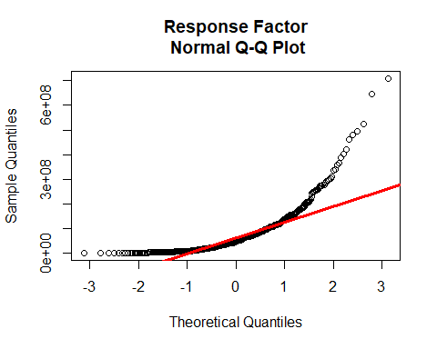 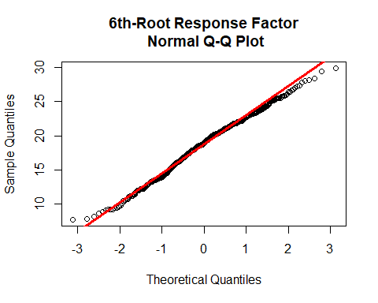

Store tRF = RF(1/6) in posdata_2, and calculate tRF_0.01 and tRF_0.99 using Eq. 1 in manuscript.

alpha = 0.01 #0.01 for 99% pred. interval  
level = 1-alpha/2  
posdata_2$RF_6thRoot <- posdata_2$RF^(1/6) #6th-root transformation  
  
#Upper prediction interval bound for a Normal 1D Distribution:  
pos_RF6th_upper<- mean(posdata_2$RF_6thRoot,na.rm=T)+qt(level,length(posdata_2$RF_6thRoot)-1)*sd(posdata_2$RF_6thRoot,na.rm=T)*sqrt(1+1/length(posdata_2$RF_6thRoot))  
  
#Lower prediction interval bound for a Normal 1D Distribution:  
pos_RF6th_lower<- mean(posdata_2$RF_6thRoot,na.rm=T)-qt(level,length(posdata_2$RF_6thRoot)-1)*sd(posdata_2$RF_6thRoot,na.rm=T)*sqrt(1+1/length(posdata_2$RF_6thRoot))

Since concentration is inversely proportional to response factor (C=I/RF), use lower prediction interval bound (tRF_0.01) to calculate upper bound concentration predictions (Conc_0.99_RF). Store predictions and error quotients in posdata_2:

#Conc_0.99_RF:  
posdata_2$Conc_DefaultRF_Upper <- posdata_2$y0/pos_RF6th_lower^6  
  
#Error Quotients:  
posdata_2$Err_RFUppervsCCEst<- posdata_2$Conc_DefaultRF_Upper/posdata_2$Conc_CC

## Method 3: Inverse Prediction Using Ionization Efficiency Estimation

See section 3.2.3 in manuscript. Load in data from Kruve, et al.:

datadir2<-'C:/Users/lgroff/OneDrive - Environmental Protection Agency (EPA)/Profile/Documents/Data/ENTACT Semi Quant/Standard Mixtures/Anneli Updates'  
posdata_anneli <- read_xlsx(paste0(datadir2,'/ENTACT_pos_pred.xlsx'))

Pre-allocate empty columns, filter updated log(IE) predictions based on DTXSID matches:

posdata_2$logIE_Pred <- NA  
posdata_anneli <- posdata_anneli[posdata_anneli$DTXSID %in% posdata_2$DTXSID,]  
for (i in 1:length(posdata_2$New_ID)){  
 #If length of matched filtered subset is > 0, store the unique log(IE)  
 #value in posdata_2.   
 if (sum(posdata_anneli$DTXSID == posdata_2$New_ID[[i]])>0){  
 posdata_2$logIE_Pred[[i]] <- as.numeric(unique(posdata_anneli[posdata_anneli$DTXSID == posdata_2$New_ID[[i]],'logIE_pred_new'])[[1]][[1]])  
 }  
 #include log(IE) for isomers (store one value for all isomers):  
 if (sum(posdata_anneli$DTXSID == posdata_2$DTXSID[[i]])>0 &   
 sum(posdata_anneli$DTXSID == posdata_2$New_ID[[i]])==0){  
 posdata_2$logIE_Pred[[i]] <- as.numeric(unique(posdata_anneli[posdata_anneli$DTXSID == posdata_2$DTXSID[[i]],'logIE_pred_new'])[[1]][[1]])  
 }  
}

## Warning: NAs introduced by coercion

Compute linear regression on log(IE) vs. tRF:

anneli_lm_pos<-lm(posdata_2,  
 formula=posdata_2$logIE_Pred~posdata_2$RF_6thRoot)

The slope is 0.0750841 and intercept is 1.5997875

Calculate 99% Prediction Interval:

anneli_predint_pos<-predict(anneli_lm_pos,  
 newdata=posdata_2,  
 interval='prediction',  
 level=0.99)

Plot results:

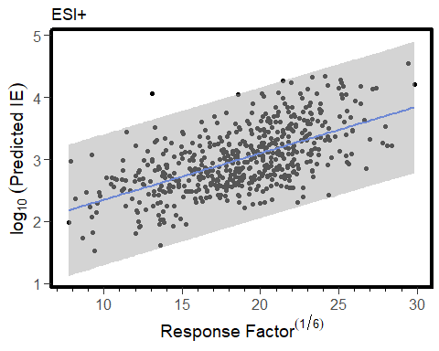

Examine fit residuals: 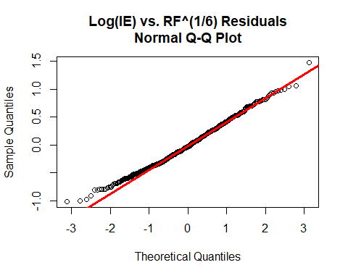

Allocate empty columns for calibrate() analysis to produce IE-predicted RFs (particularly, tRF_0.01_IE):

posdata_2$logIE_RF_0.99 <- NA  
posdata_2$logIE_RF_0.01 <- NA  
posdata_2$logIE_RF_fit <- NA

Run inverse predictions using the log IE for each chemical:

for (i in 1:length(posdata_2$RF_6thRoot)){  
 if (!is.na(posdata_2$logIE_Pred[[i]])){  
 tmpcal<-calibrate(formula=posdata_2$logIE_Pred~posdata_2$RF_6thRoot,  
 y0=posdata_2$logIE_Pred[[i]],  
 interval='inversion',  
 level=0.99)  
 posdata_2$logIE_RF_0.01[[i]]<-tmpcal$lower  
 posdata_2$logIE_RF_0.99[[i]]<-tmpcal$upper  
 posdata_2$logIE_RF_fit[[i]]<-tmpcal$estimate  
 }  
}

To ensure our error quotient is never larger than the largest error produced by the default RF method, we impute tRF_0.01 in for any tRF_0.01_IE < tRF_0.01 from the 1D tRF distribution:

for (i in 1:length(posdata_2$logIE_RF_0.01)){  
 if (!is.na(posdata_2$logIE_RF_0.01[[i]]) &  
 posdata_2$logIE_RF_0.01[[i]] < pos_RF6th_lower){  
 posdata_2$logIE_RF_0.01[[i]]<-pos_RF6th_lower  
 }  
}

Following imputation, again, we use C=I/RF_0.01_IE^6 to determine Conc_0.99_IE, and calculate the error quotients:

#Conc_0.99_IE:  
posdata_2$logIE_Conc_Upper <- posdata_2$y0/posdata_2$logIE_RF_0.01^6  
  
#Error Quotients:  
posdata_2$Err_IEUppervsCCEst <- posdata_2$logIE_Conc_Upper/posdata_2$Conc_CC